Dvar, Rosh Hashona, 2020. The Akedah

All the time, on his way back, Abraham worried what sarah would think, what she would say. where’s Izzie? she’d say.
I left him back up there on the mountain.
What do you mean, you left him there. with whom?
With god.
With god? Are you crazy? Where’s Isaac, where’s Isaac.
It’s ok, I know it’s ok. We came across Manasseh and he told us a story. And then they went off.
A story? abe. What are you talking about?
Manasseh:
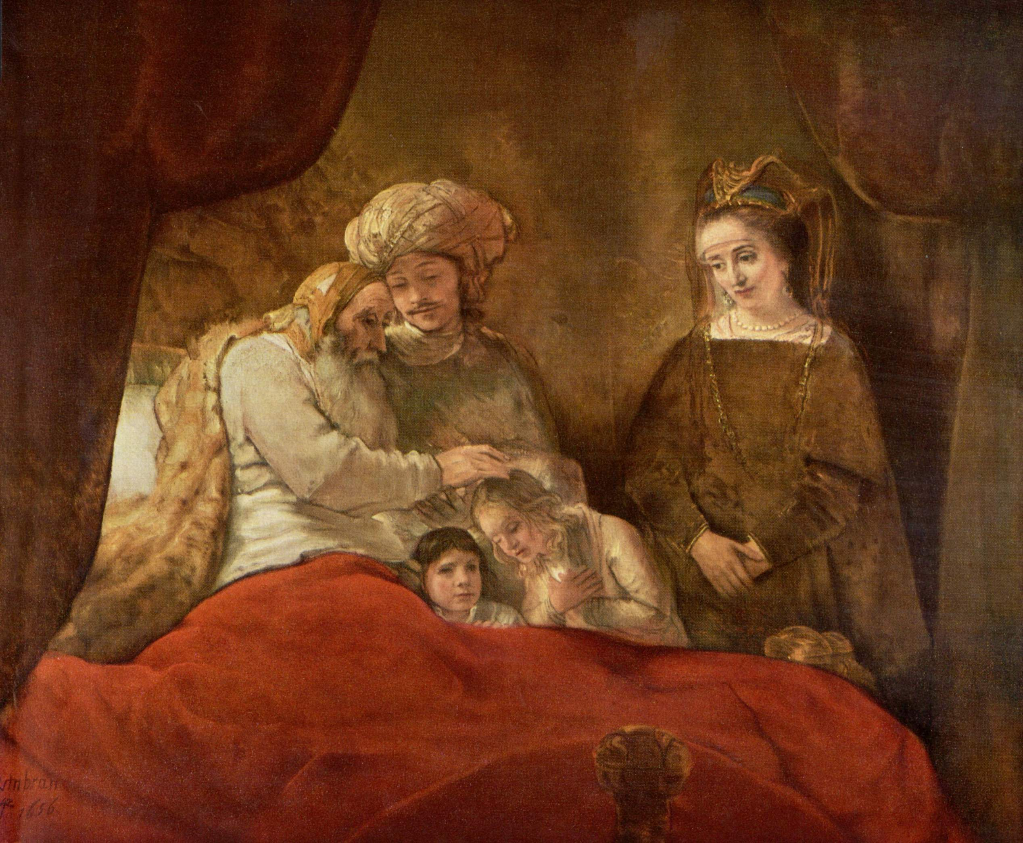
Jacob blessing the wrong son: Manasseh looks on helplessly

Well, Manasseh said he had been trying to sell those old statues from my father, you know, the ones from Ur we couldn’t unload before we left.
He had hidden them in his saddlebags, a trick his grandma had taught him, and kept them for a rainy day. He said he was really down on his luck, and he was afraid that the temple thieves would be going after him, so when he came to this really dilapidated temple, half in ruins, he figured they could be safely hidden there. In the back, under a niche of some kind, he stored them there. 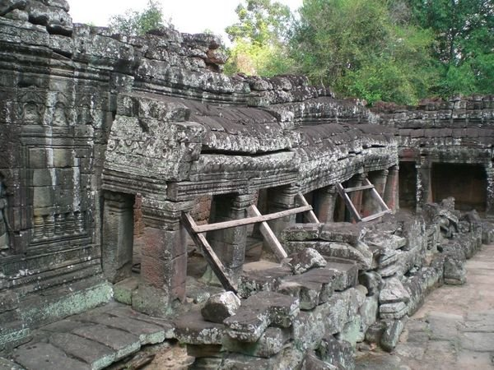

Abe, what’s this got to do with Isaac.
Wait, you’ll see.

It was a little later that Manasseh happened to be on the road to Shechem 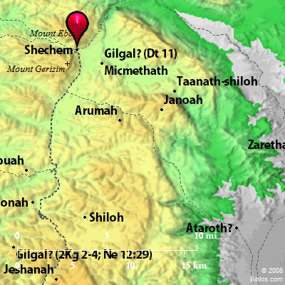
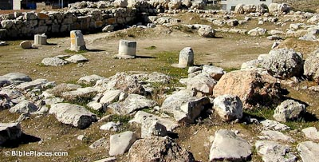
Shechem

and heard that there had been a cholera outbreak.
One of the female gods he had left behind was supposed to cure you from cholera, and he thought he should go back and fetch it. but the storms that had been brewing broke out then, and he had to take refuge. It so happened that the lean-to where we were sheltering was also where he decided to hide from the storm, and imagine our surprise when he showed up.

When I first asked what he was doing there, he was kind of evasive. He asked after the family, and I said we were all fine. We were heading to the top to make a sacrifice, and that Isaac was carrying the wood. I showed him the knife. We looked at it. It was the big one. I could see it fascinated him. He looked around. Where’s the sheep for the sacrifice, he asked.
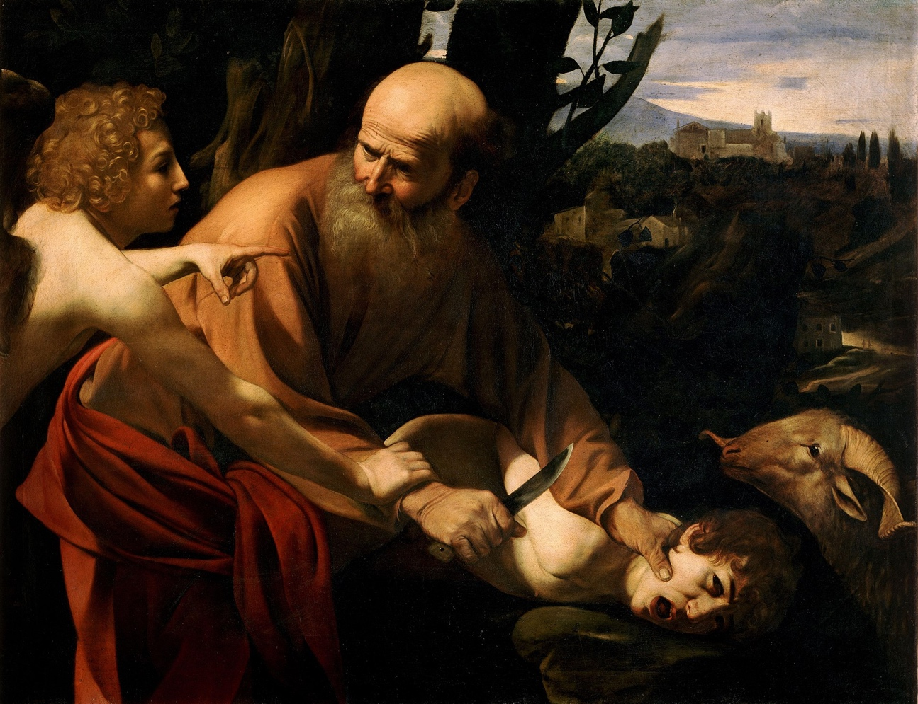
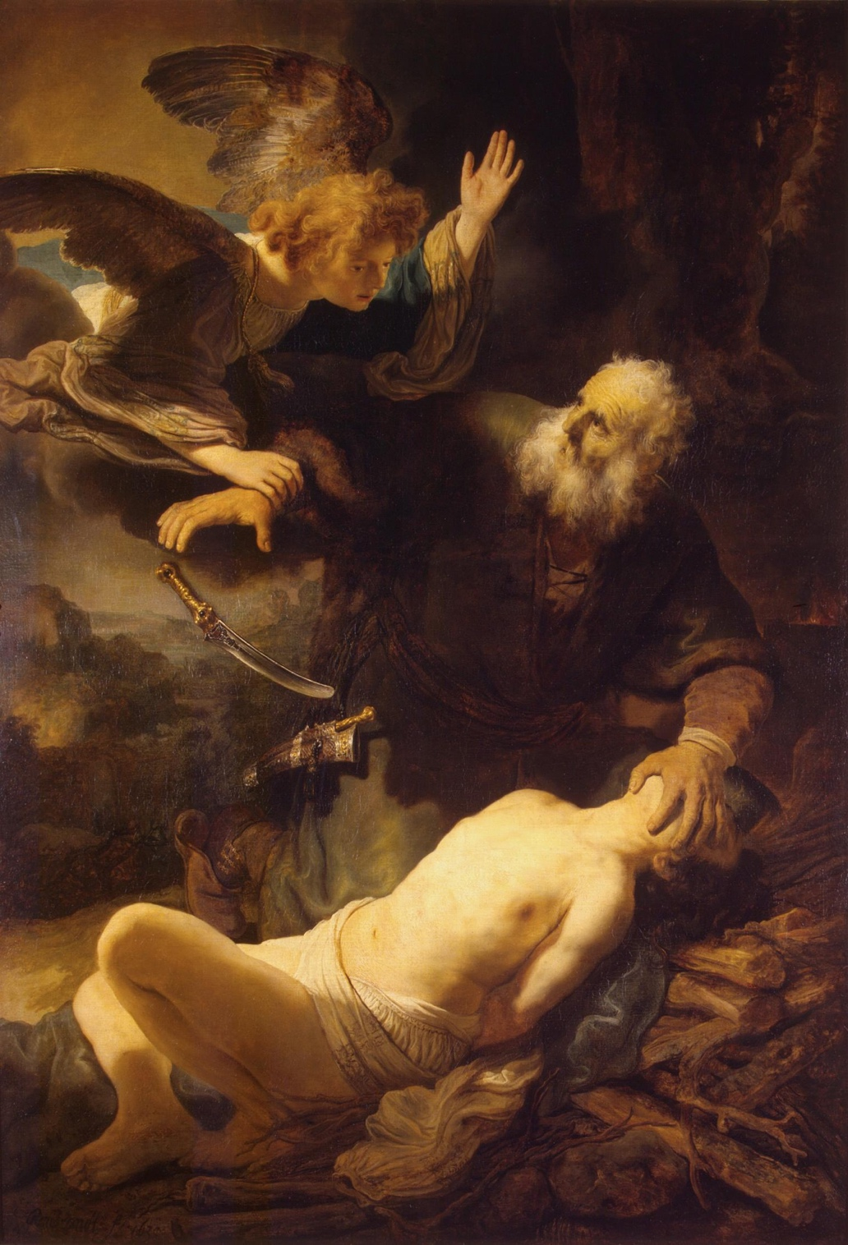

After a while, he pulled out his wallet-bag, and said, I found this on my way. It was one of
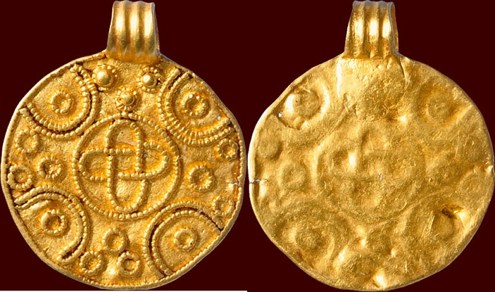
Amulet of god

those little golden amulets.
A pagan beauty.

The rain started to ease off, and he said, I have to go now.
I said, wait. Tell me first what is really going on.
I am fleeing, he admitted.
From whom, I asked.
I told you, the temple thieves.
They wouldn’t be chasing you here.
All right, he said, it wasn’t them.
Who then?
God.

I paused. Are you crazy?

Before I came here, he said, I tried to escape by the sea. But the sailors in Jaffa had word of me, and didn’t want to run the risk of taking me. So I decided to go to the shrine, to make expiation, to throw myself on god’s mercy. Only I had no sheep, not even a bird, to make an offering. To tell you the truth, I thought about dying. I was on my way and got lost. I was afraid of the people of Shechem down below after everything Dinah’s brother’s did to them, and only when it started pouring did I decide to shelter here.

I know the real story, said Isaac, who spoke up then. You didn’t really believe all that stuff about people being sacrificed, I mean children. Did you?
Manasseh said, I didn’t until I saw it in Ninevah where the people were dying like flies. 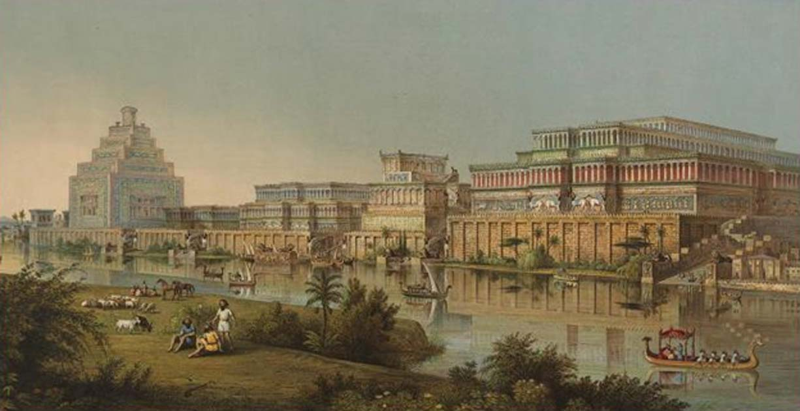
I thought it would be my turn next. I couldn’t go home because of those statues I took. Now I’m in real trouble, I’m lost. And wet. That’s why I kept going till I reached here.

Listen Manasseh, said Isaac, I learned about this in shul. One of our teachers read this story to us for the festival. The one where there are two goats; one to go free, the other, to be killed.
Which are you, Manasseh laughed.

Isaac went on. It was actually told a long time ago, but contains a prediction about the future. About a time when there would be a plague of cholera, and the one charged with saving the people was fleeing. He was afraid if he failed, they would sacrifice him. He didn’t know that his grandmother already had learned of his fate in a dream where she spoke to god.
I know, said Manasseh, one of those fairy tales.
Right, said Isaac, a fairy tale about umma Rachel and god. I’ll tell you what we read in the midrash, and you can tell me what it means.

Then Isaac continued:
It begins, Rachel was weeping for her children: The Midrash Aggadah 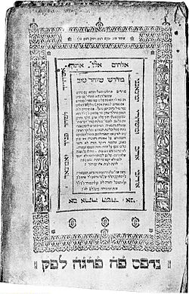
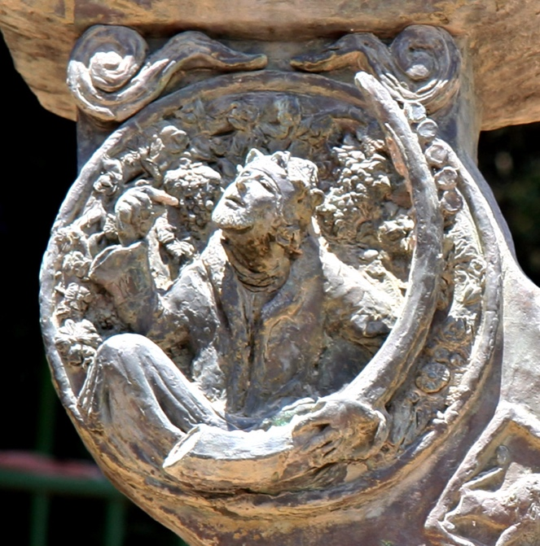
The aggadah depicting Solomonic wisdom

states that the Patriarchs and the Matriarchs went to appease the Holy One blessed be He concerning the sin of Manasseh—not you of course, just someone with a name like yours--Manasseh who placed an image in the Temple. But God was not appeased. Rachel entered and stated before Adonai, “O Lord of the Universe, whose mercy is greater, Your mercy or the mercy of a flesh and blood person? You must admit that Your mercy is greater. Now did I not bring my rival into my house? For all the work that Jacob worked for my father he worked only for me. When I came to enter the nuptial canopy, they brought my sister, and it was not enough that I kept my silence, but I gave her my password. You, too, Adonai, if Your children have brought Your rival into Your house, keep Your silence for them.” God said to her, “You have defended them well. There is reward for your deed and for your righteousness, that you gave over your password to your sister.”
15
So says Adonai: Refrain your voice from weeping and your eyes from tears, for there is reward for your work, says Adonai, and they shall come back from the land of the enemy.
16And there is hope for your future, says the Lord, and the children shall return to their own border.

That’s it, said Manasseh?
Yes, that’s it.
The children shall return to their own border.
Ah, said Manasseh. You mean I can go home now? It’s safe?
It’s maybe never really safe, said Isaac, but you will be ok. I know the roads around here, really well. I can show you the way. I’ll go with you.

Manasseh looked at me.
What about the sacrifice, he asked me.
That can wait till another day, I said. The boy knows the roads around here like the back of his hand. You won’t get lost if he leads you. I’ll take care of it myself, and then go back to tell Sarah he’ll be late.

That’s what really happened on Mount Moriah, Sarah. Forget all that stuff about the ram in the thicket, the angel and the knife. Never happened.
A week later Isaac turned up, all right. Manasseh had returned home with no problem. It seemed god had forgiven him. Soon after that the plague of cholera ended.

When Isaac grew up and had two sons he taught them the blessing. Adonai sarah, adonai rivka, adonai Rachel ve leah. And then the password. May you be like Sarah, Rebecca, Rachel, and Leah.
יְשִׂימֵךְ אֱלֹהיִם כְּשָׂרָה רִבְקָה רָחֵל וְלֵאָה
Yesimech Elohim k’Sarah Rivka Rachel v’Leah

We’ve used it ever since.

And Sarah was appeased.
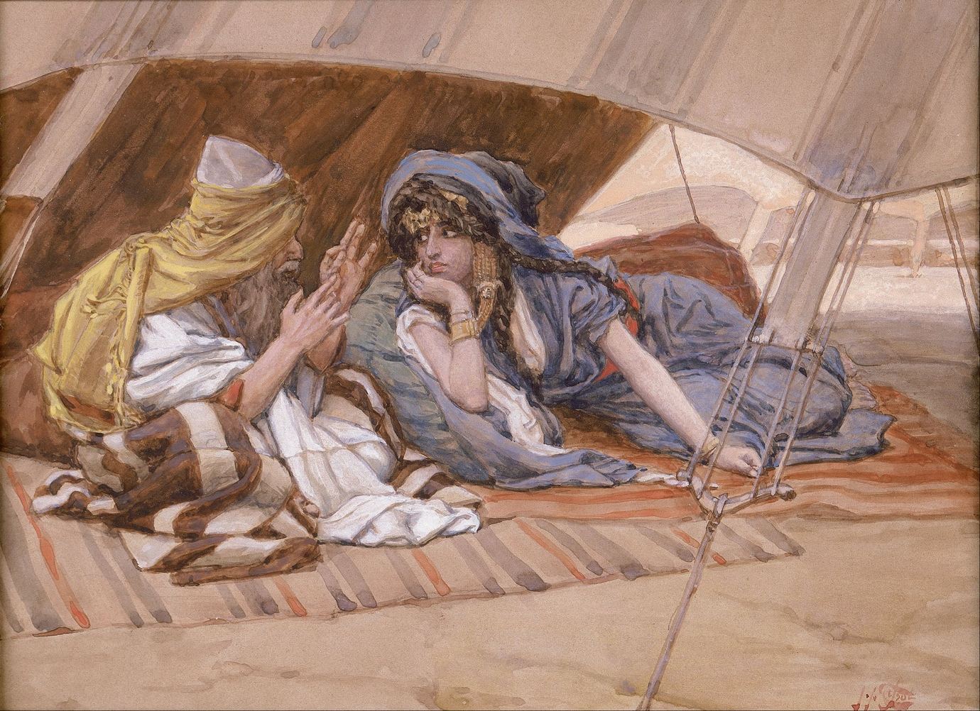
James Tissot, Abraham and Sarah

Hag sameach.

